**Assignment documentation PART-A**

Requirement elicitation : n/a

**USE CASE DIAGRAM**

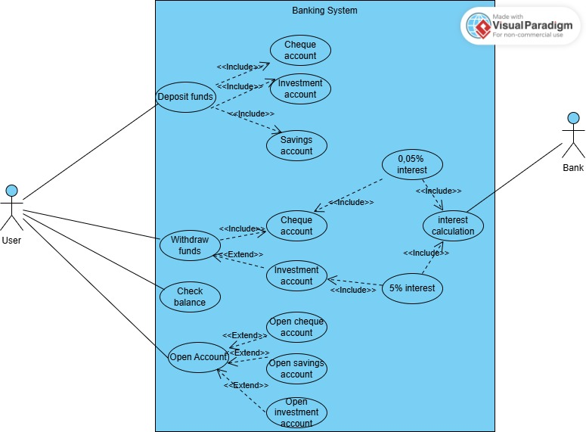

**CLASS DIAGRAM**

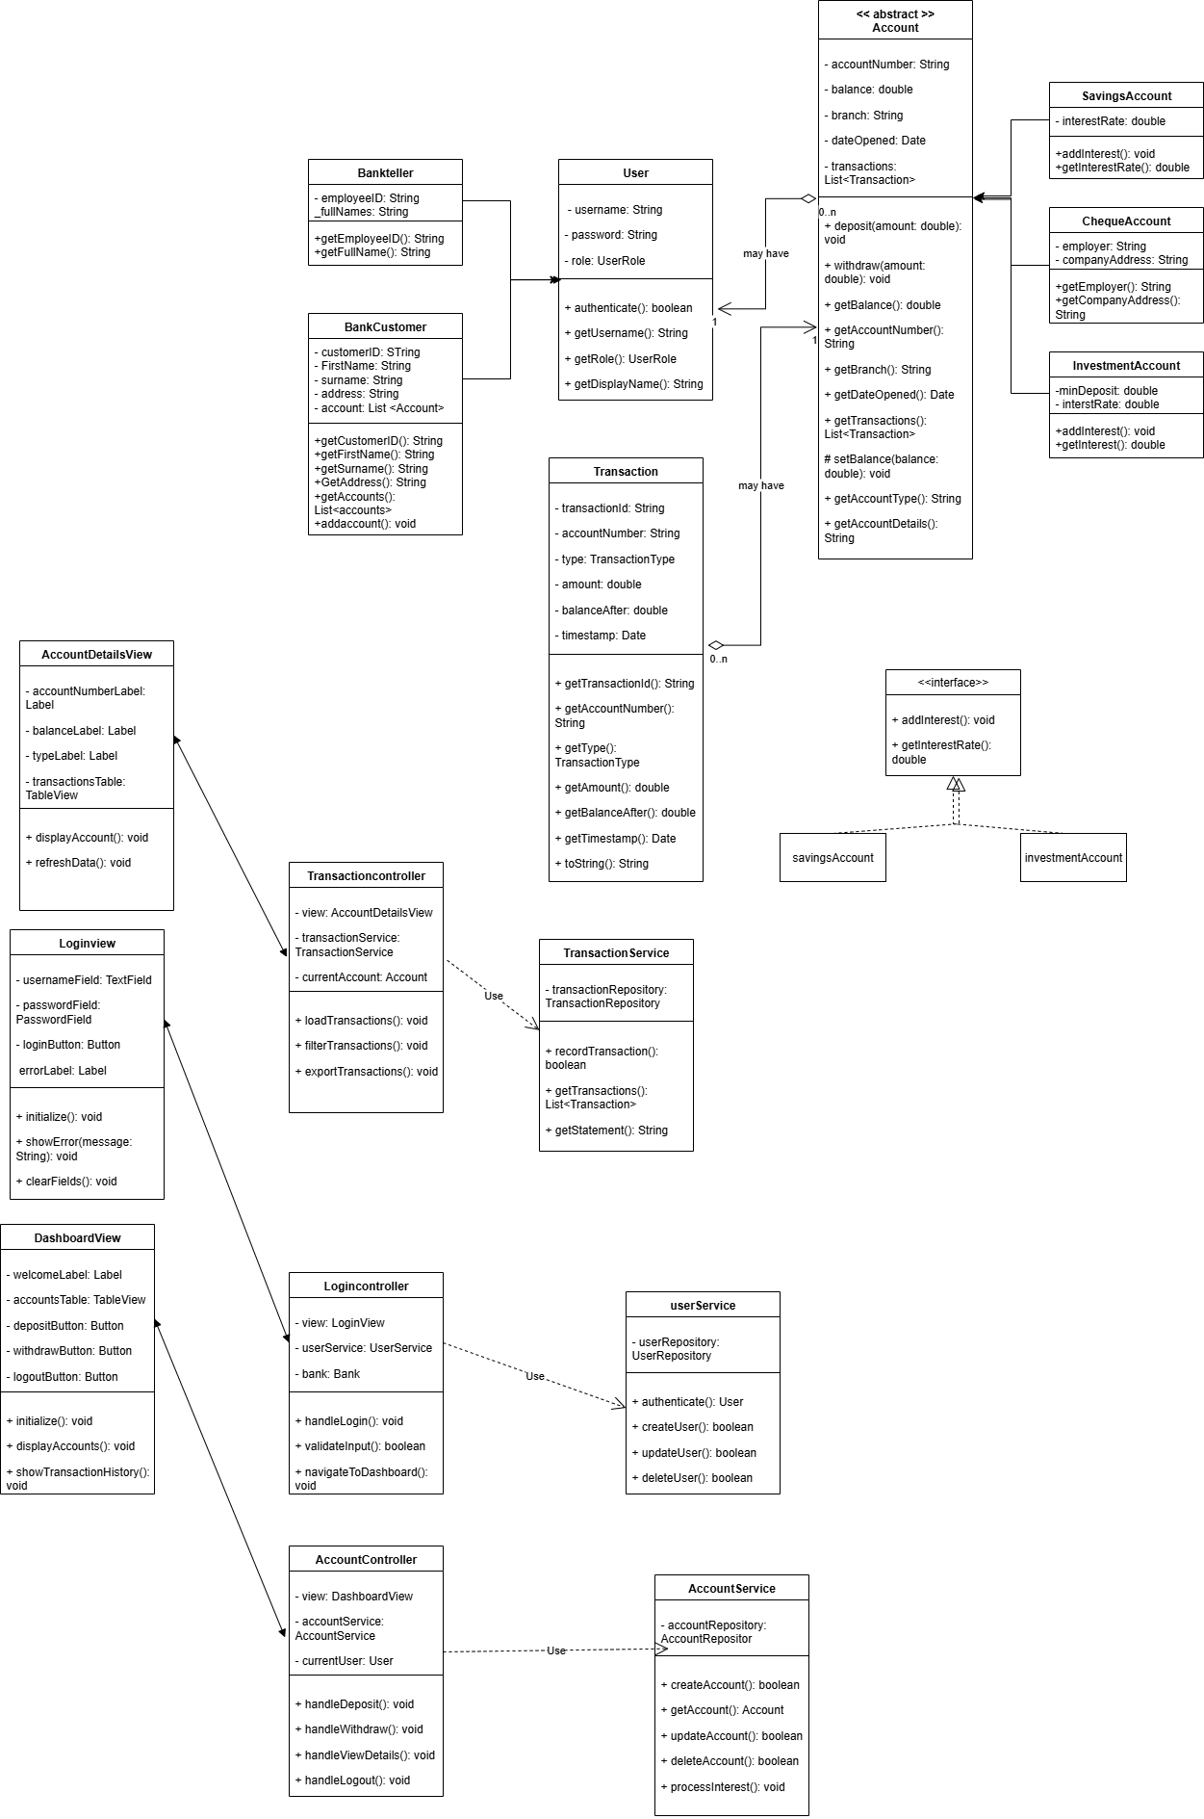

SEQUENCE DIAGRAMS

Sequence diagram for deposit

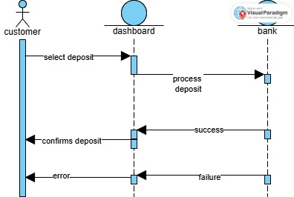

Sequence diagram for logging into the system

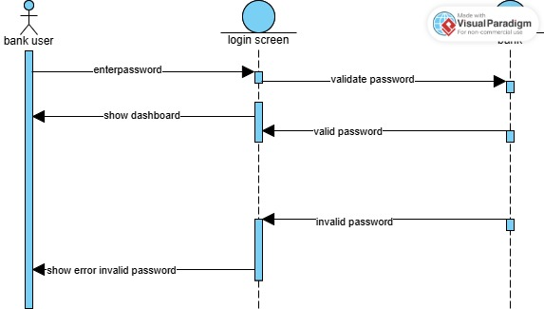

**STATE DIAGRAM**

